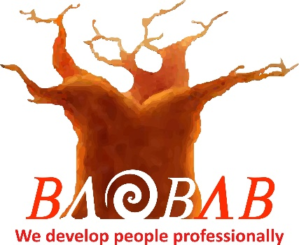

**HOSPITALITY**

**Highfield Level 2 Certificate in Hospitality and Catering Principles (Beverage Service) (RQF)**

The objective of this qualification is to provide knowledge, skill and behaviours to learners wanting to enter the Beverage/Bar Service Department within Hospitality as a Barman/lady or those already employed in such roles wishing to expand their knowledge of effective Beverage Service.

**Unit Standards**

**Unit 1 – Safe, hygienic and secure working environments in Hospitality**

**Unit 2 – Effective Teamwork**

**Unit 3 – Giving Customers a positive impression**

**Unit 4 – Principles of Customer Service in Hospitality Leisure, Travel and Tourism**

**Unit 5 – Cocktail Service**

**Unit 6 – Wine Service**

**Unit 7 – Alcoholic and non-alcoholic drink service**

**Unit 8 – Preparing and clearing Bar Areas**

**Unit 9 – Maintaining Cellars and Kegs**

**Unit 10 – Receiving, storing and issuing drinks stock**

**Unit 11 – Dealing with Payments**

**Unit 12 – Customer Complaint Handling**

**Assessment Methods**

This qualification is assessed through the completion of a Port Folio of Evidence (POE) that will be assessed by the Training Centre. The learner will demonstrate knowledge, skill and behaviour in terms of the required assessment criteria in the following manner:

**Knowledge Criteria–** Worksheets, records of oral & written questioning, assignments, projects, reports, record of professional discussion

**Skills & Behaviour Criteria-** Assessor observation, witness testimony, record of professional discussion as well as learner and peer reports

A pass/fail determination will be the conclusion of this qualification dependant on the Learner POE submitted as well as the practical outcomes achieved as recorded and verified by the BDS Assessor and Moderator.

A workbook will be provided for the learner to complete via written answers, oral discussion notes and/or oral questioning by the Facilitator.

**How long will it take me to achieve this qualification?**

The total qualification time for this qualification is 15 days of guided learning and POE building.

**Where can this course be taken?**

Baobab Development Solutions – Cape Town – South Africa

Qualification Number: 600/7919/8 Credit Value: 13